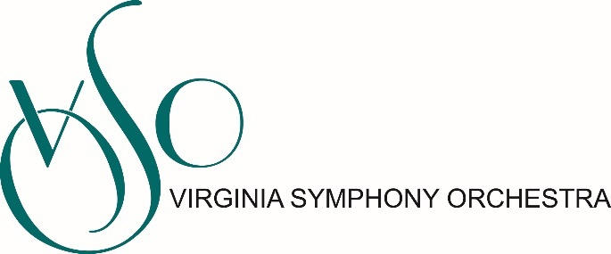

JOB DESCRIPTION
Updated January 2023

Position: Director of Marketing, Sales and Communications
Department: Marketing
Reports to: President & CEO
Direct Reports: Database Manager, Sales Manager, Patron Services Manager, House Manager, Patron Services Associate
Status: Full-time, Exempt

The Director of Marketing and Sales reports to the President & CEO and works closely in alignment with a comprehensive patron services team. They are responsible for executing successful sales and customer service campaigns that meet the VSO’s earned revenue goals. This team leader will develop a comprehensive plan to drive attendance and revenue goals for all performances and events. They’ll oversee patron development, ticketing operations, group sales, telemarketing efforts and customer service.

Principal Responsibilities:

Earned Revenue
- Establish earned revenue projections for subscription and single ticket campaigns for all ticketed concerts
- Design and implement strategies to meet earned income goals. Monitor sales trends to effectively use dynamic pricing to optimize revenue when possible
- Manage the design, production, and purchase of print, online, and electronic media as well as direct marketing efforts to meet earned income goals
- Develop and manage a comprehensive telemarketing campaign, coordinating efforts with the Development department to ensure an effective patron-focused approach
- Conduct pre- and post-campaign analysis focused on indicators such as return on investment, cost of sales, pricing analysis, market trends, consumer satisfaction, and product preference
- Track and evaluate all revenue channels (print/broadcast/direct mail/telemarketing/e-commerce) to inform future campaigns. Complete timely wrap-up reports of individual series campaigns analyzing future opportunities and challenges based on comprehensive analysis
- In partnership with the Development department design and implement patron retention strategies to engage and maintain highest level of patron loyalty for the organization
- Establish the overall strategy and supervise the execution of all ticketing and promotional activities to further the “off-stage” presence of the VSO through non-earned revenue generating community performance opportunities
- Provide pricing data to position products, packages, and services to achieve maximum sales potential
- Work with contributed revenue team to establish best practices and strategy for communications between annual fund and subscription campaigns to achieve both maximum revenue and patron satisfaction
- Any other assignments that help drive the VSO forward-thinking vision, achieve our mission, and abide by our organization’s values

Strategic Communication and Branding
- Support the creation and execution of public relations campaigns for revenue and awareness generating initiatives in consultation with senior leadership team and Media and Communications Manager
- Secure and maintain financially beneficial relationships with all media
- Support the creation and execution of program book in coordination with Media and Communications Manager
- Support Media and Communications Manager program for communicating the VSO’s plans and activities to the media. Work to establish and maintain positive contacts with local media outlets. Act as spokesperson as needed and provide public information by request.
- Develop and implement social media strategies for revenue generating initiatives (Facebook, Twitter, Instagram, YouTube, etc.)

Professional Requirements
- B.S. in Marketing preferred or demonstrated skills and competencies
- Successful leadership experience achieving earned revenue goals in the arts or related field
- Enthusiastic self-starter, with ability to inspire others and to lead a creative team in the development and implementation of a comprehensive and data-driven sales and customer service plans
- Able to work under pressure with limited resources to produce results; multi-tasking, time management, organizational, planning, team-building and leadership skills imperative
- Excellent verbal and written communication skills
- Thorough understanding of existing and emerging and best practices in marketing, especially those specific to the performing arts
- Demonstrated commitment to leadership in the areas of equity and access and an ability to articulate and achieve goals of increasing engagement with new demographic groups.
- Significant knowledge of online marketing and ability to integrate social and digital media into communications and marketing efforts
- Knowledge of classical music and Tessitura software a plus
Other Details
Salary: $70,000 annually, plus excellent benefits, including health insurance and leave.
The Director of Marketing is expected to work weekend and evening hours. If you are hired, we will require you to prove that you have received the COVID-19 vaccine or have a valid religious or medical reason not to be vaccinated.
To Apply
Interested candidates should send a cover letter and resume to Andrea Warren, President and CEO at awarren@virginiasymphony.org

VSO Statement on Attracting Candidates from All Backgrounds
Equity, Diversity, and Inclusion are music to our ears! The Virginia Symphony Orchestra is an Equal Opportunity Employer committed to increasing diversity among our applicant pool, our musicians, our staff, our board of directors, and in our program offerings. We strongly encourage people from all backgrounds, especially Black, Indigenous, and all People of Color, as well as people with non-traditional experience and educational backgrounds, to apply for this position.

