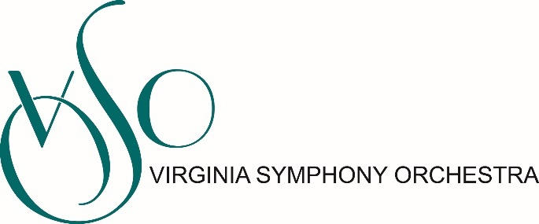

Position: Marketing Manager
Department: Marketing
Reports to: Director of Marketing
Direct Reports: Sales Manager
Status: Full-time, Exempt

JOB DESCRIPTION

The Marketing Manager reports to the Director of Marketing and works closely in alignment with a comprehensive patron services team. They are responsible for delivering ticketing campaigns (single ticket and subscriptions) that meet our exceed budget targets and demonstrate measurable growth in audience engagement (as measured through NTF metrics, ST & SUB retention metrics, multi-buying rates, subscriber acquisition rates). This team leader will develop a comprehensive plan to drive attendance and revenue goals for all performances and events.

Principal Responsibilities:

Earned Revenue
- Establish earned revenue projections for subscription and single ticket campaigns for all ticketed concerts
- Design and implement strategies to meet earned income goals. Monitor sales trends to effectively use dynamic pricing to optimize revenue when possible
- Manage the design, production, and purchase of print, online, and electronic media as well as direct marketing efforts to meet earned income goals
- Conduct pre- and post-campaign analysis focused on indicators such as return on investment, cost of sale, pricing analysis, market trends, consumer satisfaction, and product preference.
- Track and evaluate all revenue channels (print/broadcast/direct mail/telemarketing/e-commerce) to inform future campaigns. Complete timely wrap-up reports of individual series campaigns analyzing future opportunities and challenges based on comprehensive analysis.
- Provide pricing data to position products, packages, and services to achieve maximum sales potential.
- Work with contributed revenue team to establish best practices and strategy for communications between annual fund and subscription campaigns to achieve both maximum revenue and patron satisfaction.
- Any other assignments that help drive the VSO forward-thinking vision, achieve our mission, and abide by our organization’s values.
- Ensure marketing efforts are properly tracked in Tessitura for effective reporting and uphold overall data
- Act as backup for sales and patron services team when needed providing exemplary customer service for all ticketing and donation needs.
Strategic Communication and Branding
- Support the creation and execution of public relations campaigns for revenue and awareness generating initiatives in consultation with senior leadership team and Communications Manager
- Secure and maintain financially beneficial relationships with all media
- Support the creation and execution of program book in coordination with Communications Manager with the lens of sales
- Support Communications Manager program for communicating the VSO’s plans and activities to the media. Work to establish and maintain positive contacts with local media outlets.
- Develop and implement social media strategies for revenue generating initiatives (Facebook, Twitter, Instagram, YouTube, etc.)

Professional Requirements
- Successful leadership experience achieving earned revenue goals in the arts or related field
- Enthusiastic self-starter, with ability to inspire others and to lead a creative team in the development and implementation of a comprehensive and data-driven sales and customer service plans
- Able to work under pressure with limited resources to produce results; multi-tasking, time management, organizational, planning, team-building and leadership skills imperative
- Excellent verbal and written communication skills
- Thorough understanding of existing and emerging and best practices in marketing, especially those specific to the performing arts
- Demonstrated commitment to leadership in the areas of equity and access and an ability to articulate and achieve goals of increasing engagement with new demographic groups.
- Significant knowledge of online marketing and ability to integrate social and digital media into communications and marketing efforts
- Knowledge of classical music and Tessitura software a plus
Other Details
Salary: $42,000 annually, plus excellent benefits, including health insurance and leave.
Marketing Manager is expected to work weekend and evening hours. If you are hired, we will require you to prove that you have received the COVID-19 vaccine or have a valid religious or medical reason not to be vaccinated.
To Apply
Interested candidates should send a cover letter and resume to Andrea Warren, President & CEO at awarren@virginiasymphony.org

VSO Statement on Attracting Candidates from All Backgrounds
Equity, Diversity, and Inclusion are music to our ears! The Virginia Symphony Orchestra is an Equal Opportunity Employer committed to increasing diversity among our applicant pool, our musicians, our staff, our board of directors, and in our program offerings. We strongly encourage people from all backgrounds, especially Black, Indigenous, and all People of Color, as well as people with non-traditional experience and educational backgrounds, to apply for this position.

