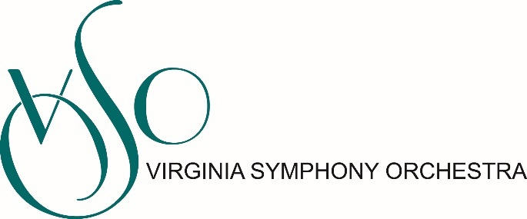
Position: Patron Services Associate
Department: Marketing
Reports to: Patron Services Manager
Status: Part-Time, Non-Exempt
The Patron Services Associate is a part-time position, supporting the functions of the Virginia Symphony Orchestra Box Office by providing customer service support in subscriptions and single ticket sales in the office as well as at the multiple concert venues in which the orchestra performs. The ideal candidate will be self-motivated, well organized, personable and is comfortable working with and analyzing data as well as excellent customer service skills and be able to make decisions quickly based on defined policies and procedures. Knowledge of Tessitura database and appreciation for symphonic music is a plus.
Primary Responsibilities:
- Serve on the front line of the Patron Services team, ensuring that all incoming calls are answered in a timely manner
- Provide excellent customer service to patrons by processing subscription, single ticket, and group sales orders; processing exchanges and other requests for subscribers; and processing comp requests
- Serve as Box Office Manager or ticketing support at assigned concerts
- Assist with maintaining integrity of the orchestra’s customer database, following defined protocols for data entry
- Outbound calling efforts for Marketing and Development initiatives
Other Duties
- Ensure marketing collateral is fully stocked for walk-up customers
- Assist with Marketing & Development Departments as needed
- Process outgoing mail daily
- Other departmental assignments may occur based on organizational need
- The Patron Services Associate is expected to work occasional late and weekend hours

Compensation: $13/hour
Patron Services Associate is expected to work weekend and evening hours. If you are hired, we will require you to prove that you have received the COVID-19 vaccine or have a valid religious or medical reason not to be vaccinated.
To Apply
Interested candidates should send a cover letter and resume to Anya Simmons, Patron Services Manager at asimmons@virginiasymphony.org
VSO Statement on Attracting Candidates from All Backgrounds
Equity, Diversity, and Inclusion are music to our ears! The Virginia Symphony Orchestra is an Equal Opportunity Employer committed to increasing diversity among our applicant pool, our musicians, our staff, our board of directors, and in our program offerings. We strongly encourage people from all backgrounds, especially Black, Indigenous, and all People of Color, as well as people with non-traditional experience and educational backgrounds, to apply for this position.

